**Assignment 2 Cover Sheet**

**IT1060 – Software Process Modeling Semester 2** - **2023**

|  |  |
| --- | --- |
| **PROJECT ID** | MLB_4.01_04 |
| **CASE STUDY NAME** | Vehicle insurance management system |
| **CAMPUS/CENTER** | Malabe |

**Assignment 2 Certify Sheet**

**IT1060 – Software Process Modeling Semester 2** - **2023**



**BSc**

**(**

**Hons) in Information Technology**



|  |
| --- |
| We hereby certify,  The attached is our own work and no further changes will be made.  We have contributed in this assignment to the best of our ability.  And we understand,  We may be subject to student discipline processes in the event of an act of academic misconduct by us including an act of plagiarism or cheating. |

|  |  |  |  |  |
| --- | --- | --- | --- | --- |
|  | ALWIS D A C | IT22326904 | 28.05.2023 |  |

**2.1) Subsystem of vehicle insurance management system (document management system)**

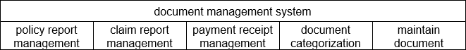

**1.2) Activity diagram**

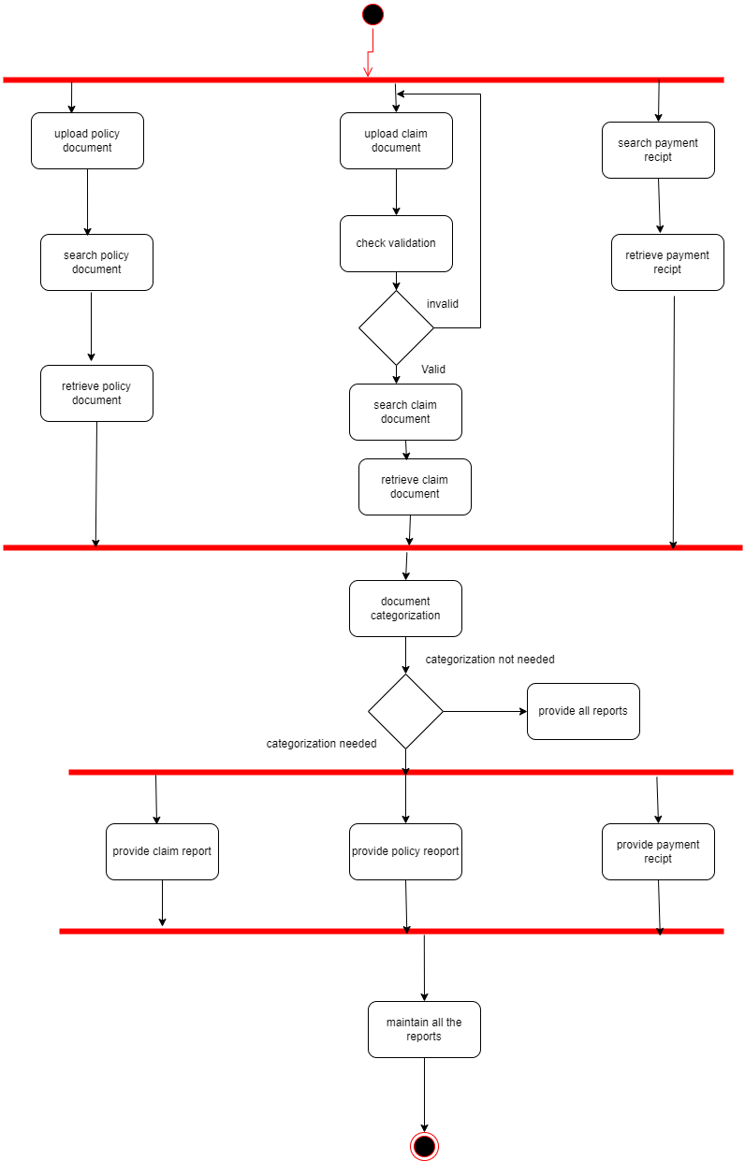

**2.2) Activity diagram with swim lanes**

|  |  |  |
| --- | --- | --- |
| **Number** | IT22326904 | |
| **Name** | Document management system | |
| **Summary** | Manage document | |
| **Pre-conditions** | User login to the system | |
| **Post-conditions** | Maintain and store all the documents | |
| **Primary Actor** | System manger , customer | |
| **Main Scenario** | **Step** | **Action** |
|  | 1 | System manager can upload policy document |
| 2 | Customer search policy document |
| 3 | Customer retrieve the policy document |
| 4 | Customer upload claim document |
| 5 | System manager search claim document |
| 6 | System manager retrieve claim document |
| 7 | Customer search payment receipt |
| 8 | Customer retrieve payment receipt |
| 9 | System categorize all the documents according to the type. |
| 10 | System provide policy report to higher management. |
|  | 11 | System provide claim report to system manager. |
|  | 12 | System provide payment receipt to customer. |
| **Extensions** | **Step** | **Action** |
|  | 4.1 | If document is not valid customer should upload the document again. |
| 9.1 | If categorization doesn’t need , system provide all the document. |
|  |  |
|  |  |
|  |  |